

**Western Australian Certificate of Education**

**Examination - Semester One, 2015**

**Marking Key**

Please place your student identification label in this box

**MUSIC:**

**WESTERN ART**

**Stage 3**

|  |  |  |  |  |  |  |  |  |  |  |
| --- | --- | --- | --- | --- | --- | --- | --- | --- | --- | --- |
| Student Number: In figures |  |  |  |  |  |  |  |  |  |  |

In words

**Time allowed for this paper**

Reading time before commencing work: Ten minutes

Working time for paper: Two hours and thirty minutes

**Materials required/recommended for this paper**

***To be provided by the supervisor***

Number of additional

answer booklets used

(if applicable):

This Question/Answer Booklet

Music Score Booklet

***To be provided by the candidate***

Standard items: pens (blue/black preferred), pencils (including coloured), sharpener, correction tape/fluid, eraser, ruler, highlighters

Special items: nil

**Important note to candidates**

No other items may be taken into the examination room. It is **your** responsibility to ensure that you do not have any unauthorised notes or other items of a non-personal nature in the examination room. If you have any unauthorised material with you, hand it to the supervisor **before** reading any further.

**Structure of this paper**

|  |  |  |  |  |  |
| --- | --- | --- | --- | --- | --- |
| Section | Number of questions available | Number of questions to be answered | Suggested working time  (minutes) | Marks available | Percentage of exam |
| Section One:  Aural and analysis | 7 | 7 | 45 | 48 | 35 |
| Section Two:  Cultural and historical analysis  Part A:  Analysis  Part B:  Short response  Part C:  Extended response | 1 | 1 | 60 | 20 | 10 |
| 1 | 1 | 20 | 12 |
| 2 | 1 | 20 | 13 |
| Section Three:  Music skills | 4 | 4 | 45 | 37 | 30 |
|  |  |  |  | **Total** | 100 |

**Instructions to candidates**

1. Write your answers in this Question/Answer Booklet.
2. The examination is structured as follows:

Section One is common to **all** contexts and contains questions which require you to listen and respond to a selection of music excerpts.

Section Two is context-specific and comprises **three (3)** parts:

Part A: contains **one (1)** question based on the compulsory area of study that requires you to listen to a music excerpt and respond to the score provided.

Part B: contains **one (1)** question based on the compulsory area of study and score/s from the

correlating designated work.

Part C: requires you to respond to **one (1)** question based on the non-compulsory area of study and the correlating designated works.

For Semester One, you may answer this question based on the same area of study as Part B.

Section Three is context-specific and contains composition tasks and theory questions.

1. You must be careful to confine your responses to the specific questions asked and to follow any instructions that are specific to a particular question.
2. Spare pages are included at the end of this booklet. They can be used for planning your responses and/or as additional space if required to continue an answer.
   * Planning: If you use the spare pages for planning, indicate this clearly at the top of the page.
   * Continuing an answer: If you need to use the space to continue an answer, indicate in the original answer space where the answer is continued, i.e. give the page number. Fill in the number of the question(s) that you are continuing to answer at the top of the page.

**Sound check**

*Note to supervisors: Please ensure that all EQ levels are flat (set to 0) and that both left and right channels on your stereo system are functioning before commencing the sound check.*

Listen to the music excerpt, which follows. This is a sound check only. If you cannot hear the music please alert your supervisor by raising your hand.

Prior to the commencement of this excerpt, one bar containing the tonic triad will be played and a second bar with four beats will be heard.

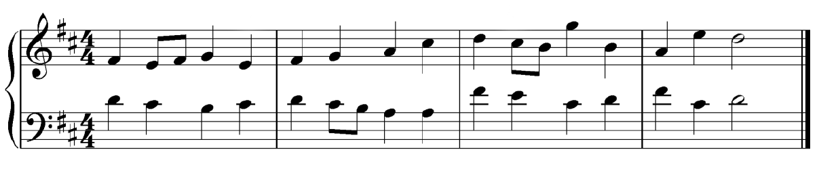

Sound check example courtesy of: School Curriculum and Standards Authority

This is the end of the sound check.

**Section One: Aural and Analysis 35% (48 Marks)**

This section has **seven (7)** questions that require you to listen and respond to a selection of music excerpts. Answer **all** questions. Write your answers in the spaces provided. A **one (1)** minute silence will follow the playing of the music for each question. You may respond to the questions throughout the duration of the playing of the music excerpts, including the one-minute silence between questions.

Spare pages are included at the end of this booklet. They can be used for planning your responses and/or as additional space if required to continue an answer.

* Planning: If you use the spare pages for planning, indicate this clearly at the top of the page.
* Continuing an answer: if you need to use the space to continue an answer, indicate in the original space where the answer is continued, i.e. give the page number. Fill in the number of the question(s) that you are continuing to answer at the top of the page.

Suggested working time: 45 minutes.

**Question 1: Interval recognition (4 Marks)**

A music excerpt will be played **three (3)** times with a 30 second pause between each playing. Write the missing notes on the stave. Identify the resulting intervals indicated by (i) and (ii).



1. Perfect 4th
2. minor 3rd

1 mark per correct interval written on the stave (must have both notes correct to receive mark)

1 mark per correct naming of interval

**Question 2: Rhythmic dictation (10 marks)**

You will hear a music excerpt played as follows, with a 30 second pause between each playing:

* the complete excerpt
* the first phrase of the excerpt played twice
* the second phrase of the excerpt played twice
* the complete excerpt played again

Insert the time signature, bar lines and rhythm to the pitches given. There are **eight** bars in total. The first note of the excerpt and the first note of the second phrase have been provided.

Prior to the commencement of this excerpt, one bar containing the tonic triad will be played followed by a second bar containing two (2) beats and a third bar with the quaver pulse.

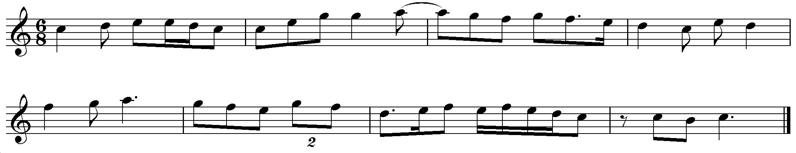

The marking for this question reflects the SCSA marking system – always round each mark to nearest whole number

1 mark for each correct note (notes in boxes were given) – 36 notes 6 marks

DO NOT count rest, tied notes counted as 1 mark, duplet counted as 1 mark (accept two dotted quavers here)

DIVIDE by 6 for a total out of 6 marks

1 mark for each correct bar line (including double at end) – 8 bar lines 2 marks

DIVIDE by 4 for a total out of 2 marks

1 mark for correct time signature 1 mark

Correct grouping (all or most) 1 mark

**TOTAL 10 marks**

**Question 3: Recognition of tonality (1 mark)**

A music excerpt will be played **two (2)** times with a 30 second pause between each playing. This excerpt may have a modulation as indicated by the bracket [a]. The melody is provided for the first section and the rhythm only for the last.

Indicate the modulation that occurs within this extract by placing a tick beside **one** of the options provided.

|  |
| --- |
| (✓) |
|  | to the relative major |
|  | to the relative minor |
| ✓ | to the dominant |
|  | no modulation |

**Question 4: Discrepancies (6 marks)**

A music excerpt will be played **four (4)** times with a 30 second pause between each playing. There are **two (2)** rhythm and **two (2)** pitch errors in this excerpt. Rhythmic errors could occur across a beat. Circle the errors and rewrite them correctly on the staff provided. The first note is correct.

Prior to the commencement of this excerpt one bar containing the tonic triad will be played and a second bar with two crotchet beats will be heard.

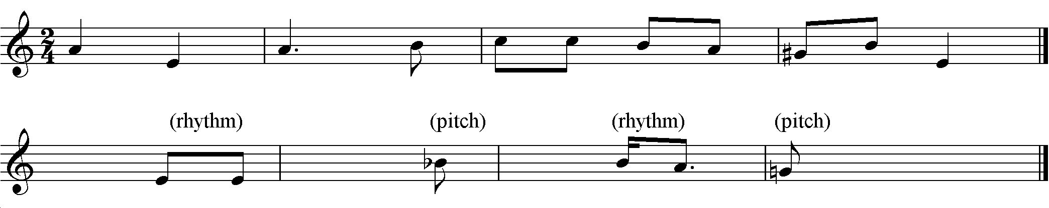

1 mark for circling both rhythmic errors (must have both correct to receive mark) 1 mark

1 mark for circling both pitch errors (must have both correct to receive mark) 1 mark

1 mark for each correction written on the stave (total of 4 marks) 4 marks

**TOTAL 6 marks**

**Question 5: Melodic dictation (12 marks)**

You will hear a music excerpt played as follows, with a 30 second pause between each playing:

* the complete excerpt
* the first phrase of the excerpt played twice
* the second phrase of the excerpt played twice
* the complete excerpt played again

Complete the melodic dictation by providing the pitch and rhythm for all **eight** bars. The first two notes have been provided.

Prior to the commencement of this excerpt, one bar containing the tonic triad will be played and a second bar with four beats will be heard.

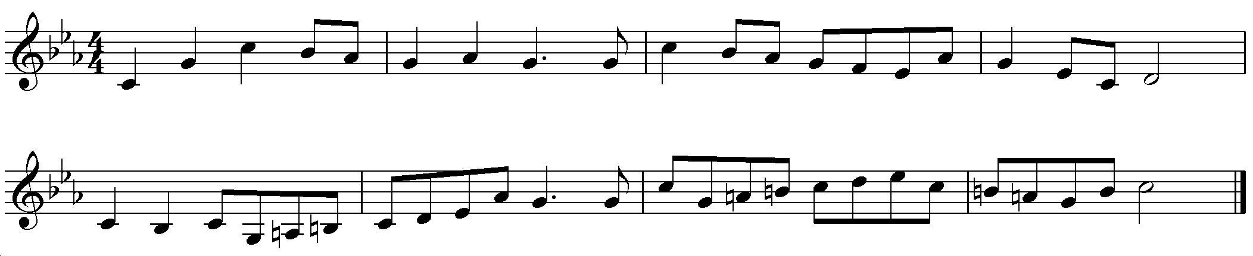

The marking for this question reflects the SCSA marking system – always round each part to nearest whole number

1 mark for every correct pitch (notes in boxes were given) – 43 notes 10 marks

Accidentals must be correct to gain the mark

DIVIDE by 4.3 for a total out of 10 marks

1 mark for each correct rhythm – 43 notes 2 marks

DIVIDE by 21.5 for a total out of 2 marks

**TOTAL 12 marks**

**Question 6: Harmonic/chord progressions (5 marks)**

A music excerpt will be played **three (3)** times with a 30 second pause between each playing.

Complete the chord analysis. Identify the **five (5)** chords indicated using Roman numerals **or** chord names as shown below. Write your answers on the lines below the arrows.

Prior to the commencement of this excerpt, the tonic chord and four beats will be heard.

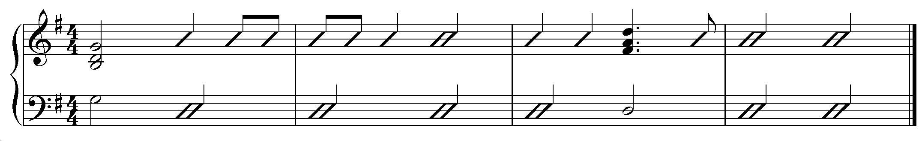

Roman

numerals ii Ib IV V7 I

**or**

Chord Am G/B C D7 G

names

1 mark per chord

**Question 7: Skeleton score (10 marks)**

A music excerpt will be played **four (4)** times with a 30 second pause between each playing.

Refer to the score on the following page to answer the questions for this section.

(a) Provide an appropriate tempo indication for this excerpt. (1 mark)

Allegro

(b) Identify the key of this excerpt. (1 mark)

A minor

(c) Name the compositional device evident in the bass line.

(1 mark)

Ostinato

(d) What scale is suggested by the melodic material in bars 3 and 4? (1 mark)

A melodic minor (do not accept ‘minor’ only or ‘harmonic minor)

(e) Complete the melody **and** rhythm for the Violin line in bars 6 and 7. Write your answer on the stave below. The first note of bar 6 is provided.

(4 marks)

See correct bars below.

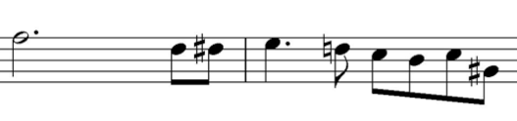

1 mark for beat 3 of bar 1 (beats 1-3 given) 1 mark

1 mark for beats 1-2 of bar 2 1 mark

1 mark for beat 3 of bar 2 1 mark

1 mark for beat 4 of bar 2 1 mark

Must have all notes of the beat/s correct to receive the mark **TOTAL 4 marks**

(f) What chord is heard in bar 7? Write your answer as a chord name **or** Roman numeral.

(1 mark)

V7 (no mark for chord V only)

(g) The Guitar chord in bar 3 contains no ‘5th’. If the performer wished to play an augmented chord, what note would they need to add?

(1 mark)

They would need to add a C (to make C E G# D or V+9)

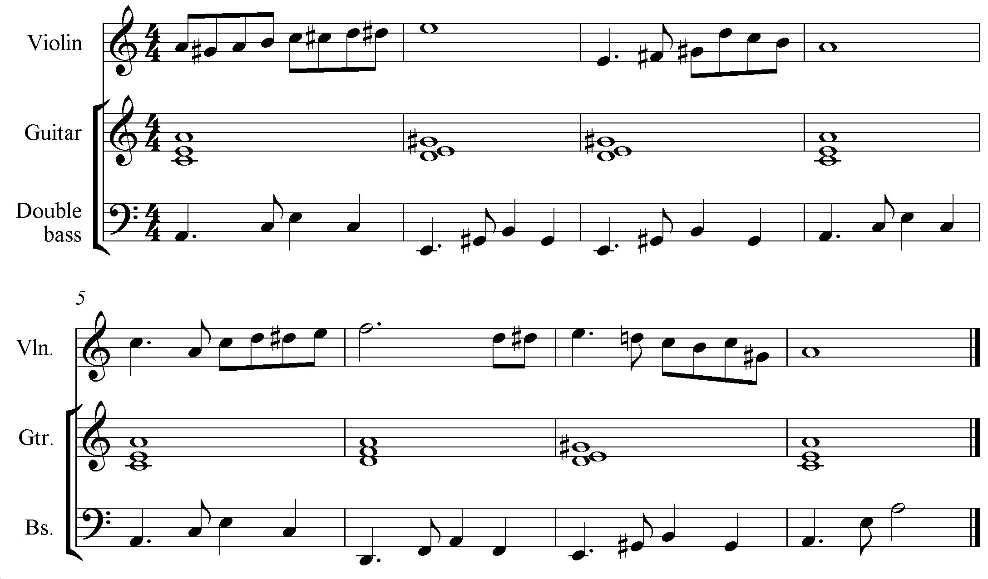

**End of Section One.**

**Section Two: Cultural and historical analysis 35% (60 Marks)**

This section has **three (3)** parts. You must answer **each** part and write your answers in the spaces provided.

Part A: contains **one (1)** question based on the compulsory area of study that requires you to listen to

a music excerpt and respond to the score provided. You may respond to the question parts throughout

the duration of the playing of the music excerpt, including the pause between each playing.

Part B: contains **one (1)** question based on the compulsory area of study.

Part C: requires you to respond to **one (1)** question based on the non-compulsory area of study.

For Semester One, you may answer this question based on the same area of study as Part B.

Spare pages are included at the end of this booklet. They can be used for planning your responses and/or as additional space if required to continue an answer.

* + Planning: If you use the spare pages for planning, indicate this clearly at the top of the page.
  + Continuing an answer: If you need to use the space to continue an answer, indicate in the original answer space where the answer is continued, i.e. give the page number. Fill in the number of the question(s) that you are continuing to answer at the top of the page.

Suggested working time: 60 minutes.

**Part A: Analysis 10% (20 Marks)**

Question 8

**Refer to the score on pages 1-3 (Excerpt One) of the Score Booklet to answer this question.**

The music excerpt will be played twice with a **two (2) minute** pause between each playing. Follow the excerpt using the score provided. You may write while the music is playing.

(a) Identify which movement this excerpt is most likely from. (1 mark)

Movement 2

(b) Name the solo instrument used in this movement. (1 mark)

Oboe

(c) Name the compositional device evident in the solo line in bars 29 to 36. (1 mark)

Suspension

(d) Provide a term to describe what is occurring between Cello 1 and Cello 2 in the opening of the excerpt.

(1 mark)

Imitation

(e) Suggest the most likely era for this excerpt and give two (2) reasons for your choice.

(3 marks)

Era: Baroque

Accept reasons such as:

- One mood/affection

- Use of terraced dynamics

- Implicated harpsichord (with senza cembalo indication)

- Use of sequences

Accept other appropriate answers.

(f) What key is suggested in bar 26? (1 mark)

D minor

(g) What is the name of the clef used for the Cellos in bar 8, and why does this change to a different clef for Cello 1 halfway through bar 9?

(2 marks)

Name of clef in bar 8: Tenor clef

Why the change of clef: The instrumental line changes octave and would be too low to write in tenor

clef, therefore is written in bass clef.

(h) The opening indicates ‘senza Cembalo’. (2 marks)

Define this indication and suggest **one (1)** effect this may have on the music.

Definition: Without harpsichord

Effect on music: Accept answers such as: Thins the texture and creates a more intimate setting, removes the chordal instrument and therefore the continuous harmonic support, creates a more mellow timbre with the removal of the ‘tinny’ harpsichord, creates contrast in the mood of this movement compared to the movements that utilise the harpsichord.

(i) Look at the final two bars of the excerpt.

(i) Name the last two chords, using Roman numerals. (1 mark)

VI and V (major chord V)

(ii) Name the cadence formed by these chords. (1 mark)

Interrupted

(iii) Describe why the final chord is major and not minor, and why this is often the case in a minor key. (1 mark)

It is major as it contains the notes D F# and A. This is often the case in a minor key due to the raised leading note (in this case the F#).

(j) The entire work from which this excerpt is taken contains five movements rather than the typical three. What do you think the style of the additional movements may be? (1 mark)

Dance-like

(k) Use the table below to compare the choice of instrumentation in this movement to Bach’s choice of instrumentation in the slow movement of the Brandenburg Concerto No 2 in F. Make **two (2)** separate points in your answer.

(4 marks)

|  |  |  |
| --- | --- | --- |
|  | **This excerpt** | **Slow movement of Bach’s Brandenburg Concerto No 2** |
| **Point One** | One solo instrument has been used (the Oboe) – a double reed which blends well with the accompanying strings. | Bach uses 4 solo instruments in the Concertino section that are all very dissimilar in tone production, but are written in a similar range. An ‘atypical’ combination of instruments for the era. |
| **Point Two** | Omission of the harpsichord in the continuo creates a thinner texture and a more mellow and contrasting mood. | Omission of the Tromba in F creates a more intimate setting and contrasts with the energy of the first movement. |

Accept other appropriate answers.

**Part B: Short response 12% (20 Marks)**

____________________________________________________________________________

Question 9: Concerto

Refer to Excerpt Two (Pages 4-8) in the Score booklet: Rachmaninoff’s *Piano Concerto No 2 in C minor Movement I*,and answer the parts of the question below.

(a) (i) What section of the movement is this excerpt taken from? (1 mark)

Development

(ii) Which theme is presented in this extract? (1 mark)

1a/Theme 1a/Subject 1a

(iii) What instruments develop this theme in the opening bars of the excerpt? (1 mark)

Oboe, Clarinet and Violas

(b) Define the following terms used in this excerpt. (2 marks)

*Moto precedente* Back to the preceding tempo/at the former tempo

*div.* divisi - divide (when more than one instrumental line on a stave)

(c) What effect would the use of a mute (con sord.) have on the overall timbre of the strings?

(1 mark)

Reduction in volume

Dampening of sound

(d) Name the technique employed by the violins at the beginning of the excerpt. (1 mark)

Tremolo

(e) Look at bar 193 (piu vivo).

(i) Which instruments have the theme here? (1 mark)

Flute and Oboe

(ii) Identify and define how the theme has been developed in this section. (2 marks)

Retrograde – rhythm has been reversed but the intervallic structure stays the same

(iii) Describe two (2) ways in which the piano line at bars 193-196 is indicative of the era in which the piece was written. (2 marks)

Accept any two from:

Use of very large range and leaps typical for the Romantic era

Use of non-diatonic notes to create colour

Use of expressive articulations i.e. staccato, accents, slurs

Use of varied dynamics – sfz, cresc/decresc over two beats etc.

(f) Identify the compositional device evident in the low strings in bars 193 – 196. (1 mark)

Descending sequence

(g) What key has been reached at bar 177 and what are two (2) ways of knowing this?

(3 marks)

Key: G minor

Accept any two from:

Raised 7th (F#) evident

A natural evident

Leading note to tonic (F# - G) prominent in Violin II line

(h) Outline and explain the characteristics of this theme in it’s original form (i.e. when it is first presented). How does this theme reflect Rachmaninoff’s compositional style?

(4 marks)

Characteristics of theme:

Russian character

Based on Russian Orthodox Church chants

Centered around the Aeolian mode (chant origin)

Con passione (with passion) indication

Originally heard in low strings in unison

1 mark per appropriate point (accept dot point answers) up to a total of 3 marks

How it reflects Rachmaninoff’s style:

Russian himself – a quasi-nationalistic theme

1 mark

**Part C: Extended response**

**Question 10 (20 marks)**

‘When one listens to a piece of music, it is often evident who the artist/composer is simply by the techniques and musical elements they employ that are specific to their compositional/writing style.’

Discuss this statement in relation to **one (1)** designated work you have studied.

|  |  |
| --- | --- |
| **Description** | **Marks** |
| **CRITERION 1: An overview of the era or style in which the piece was written.** | |
| Provides a relevant and specific overview of the era or style of the piece. | 3-4 |
| Provides a limited or general overview of the era or style of the piece. | 1-2 |
| **Sub-Total** | **4** |
| **CRITERION 2:** **A description of the compositional techniques and musical elements used by the artist/composer in the piece.** | |
| Provides relevant and specific details of the compositional techniques and musical elements used by the artist/composer. | 3-4 |
| Provides limited details of the compositional techniques and musical elements used by the artist/composer. | 1-2 |
| **Sub-Total** | **4** |
| **CRITERION 3: A discussion of how these compositional techniques and musical elements reflect the artist/composer’s style.** | |
| Provides a detailed and specific discussion on how each technique and element reflects the artist/composers writing style. | 6 |
| Provides a detailed discussion outlining a number of ways each technique and element reflects the artist/composers writing style. | 5 |
| Provides accurate information outlining some ways each technique and element reflects the artist/composers writing style. | 4 |
| Provides accurate information outlining a few ways each technique and element reflects the artist/composers writing style. | 3 |
| Provides some information but struggles to link each technique and element to the artist/composers writing style. | 2 |
| Provides limited information and struggles to link each technique and element to the artist/composers writing style. | 1 |
| **Sub-Total** | **6** |
| **CRITERION 4: Supporting reference to at least three (3) elements of music, concise examples from the designated work and use of appropriate music terminology.** | |
| Makes detailed reference to at least three of the elements of music. Uses a range of appropriate examples from the designated work and correct music terminology. | 6 |
| Makes relevant reference to at least three of the elements of music. Uses appropriate examples from the designated work and appropriate music terminology. | 5 |
| Makes some relevant reference to at least three of the elements of music. Uses mostly appropriate examples from the designated work and mostly appropriate music terminology. | 4 |
| Makes general reference to at least three of the elements of music. Uses some examples from the designated work and some music terminology. | 3 |
| Makes superficial reference to at least two of the elements of music. Uses minimal examples from the designated work and minimal music terminology. | 2 |
| Makes limited reference to at least one of the elements of music. Uses limited or no examples from the designated work and limited or no music terminology. | 1 |
| **Sub-Total** | **6** |
| **Total** | **20** |
| **NOTE: For Semester One, the response may be based on the same area of study as Part B.** | |

**Question 11 (20 marks)**

Discuss the development of a particular style/genre of music, making reference to **two (2)** designated works in support of your answer.

|  |  |
| --- | --- |
| **Description** | **Marks** |
| **CRITERION 1: An overview of the style/genre.** | |
| **For each** of the two works: | |
| Provides a relevant and specific overview of the style/genre. | 2 |
| Provides a limited or general overview of the style/genre. | 1 |
| **Sub-Total** | **4** |
| **CRITERION 2: A description of the musical characteristics and conventions used within the style/genre.** | |
| **For each** of the two works: | |
| Provides relevant and specific details of the musical characteristics and conventions used within the style/genre. | 2 |
| Provides limited or general details of the musical characteristics and conventions used within the style/genre. | 1 |
| **Sub-Total** | **4** |
| **CRITERION 3: A discussion of the development of the style/genre across two (2) or more time periods or eras** | |
| Provides a detailed and specific discussion on the development of the style/genre across two or more eras. | 6 |
| Provides a detailed discussion outlining the development of the style/genre across two or more eras. | 5 |
| Provides accurate information outlining some of the development of the style/genre across two or more eras. | 4 |
| Provides accurate information outlining a few areas of the development of the style/genre across two or more eras. | 3 |
| Provides some or general information outlining the development of the style/genre across one era only. | 2 |
| Provides limited information outlining the development of the style/genre across one era or provided limited details of the style/genre or era. | 1 |
| **Sub-Total** | **6** |
| **CRITERION 4: Supporting reference to at least three (3) elements of music, concise examples from the designated works and use of appropriate music terminology.** | |
| Makes detailed reference to at least three of the elements of music. Uses a range of appropriate examples from the designated work and correct music terminology. | 6 |
| Makes relevant reference to at least three of the elements of music. Uses appropriate examples from the designated work and appropriate music terminology. | 5 |
| Makes some relevant reference to at least three of the elements of music. Uses mostly appropriate examples from the designated work and mostly appropriate music terminology. | 4 |
| Makes general reference to at least three of the elements of music. Uses some examples from the designated work and some music terminology. | 3 |
| Makes superficial reference to at least two of the elements of music. Uses minimal examples from the designated work and minimal music terminology. | 2 |
| Makes limited reference to at least one of the elements of music. Uses limited or no examples from the designated work and limited or no music terminology. | 1 |
| **Sub-Total** | **6** |
| **Overall Total** | **20** |
| **NOTE: For Semester One, the response may be based on the same area of study as Part B.** | |

**Section Three: Music skills 30% (37 Marks)**

This section has **four (4)** questions. Answer **all** questions. Write your answers in the spaces provided.

Spare pages are included at the end of this booklet. They can be used for planning your responses and/or as additional space if required to continue an answer.

* + Planning: If you use the spare pages for planning, indicate this clearly at the top of the page.
  + Continuing an answer: If you need to use the space to continue an answer, indicate in the original answer space where the answer is continued, i.e. give the page number. Fill in the number of the question that you are continuing to answer at the top of the page.

Suggested working time: 45 minutes.

This space has been left blank intentionally.

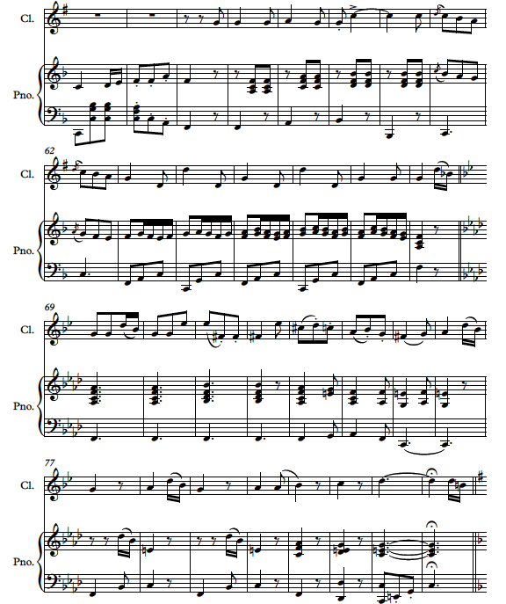

Interval

Interval

Interval

Chord

Chord

Chord

*54*

Question 12: Visual score analysis (12 marks)

**Refer to the extract on the previous page to answer this question.**

(a) Provide an appropriate time signature. (1 mark)

3/8

(b) Name the transposing instrument in this excerpt and describe its transposition. (1 mark)

Clarinet (Bb – Sounds one tone lower than written)

(c) Name the key that the excerpt moves to in bar 69. (1 mark)

F minor

(d) Name the type of ornamentation evident in bar 62. (1 mark)

Acciaccatura

(e) Identify the interval formed between the two notes marked on the score as follows. (3 marks)

LH Piano line Bar 64: Perfect 5th

Clarinet line Bar 68: Major 3rd

RH Piano line Bar 79/80: Diminished 5th

(f) Assuming that the key of the opening is F major; identify the chords marked by the boxes in

the following bars using **Roman numerals**.

(3 marks)

Bar 55: Ic

Bar 59: IV

Bar 62: V (accept V7 due to the Bb in the clarinet line)

(g) Identify one (1) of each of the following compositional devices in the score. Provide bar

numbers to indicate where it occurs.

(2 marks)

Sequence: Bar numbers as appropriate (i.e. Bars 63-66 RH piano line)

Vamping accompaniment: Bar numbers as appropriate (i.e. Bars 57-60 piano)

(2 marks)

**Question 13: Transposition (6 marks)**

A transposed Brass Quintet score is below. The trombone and tuba are in concert pitch. All other parts have been written to sound at concert pitch when played.

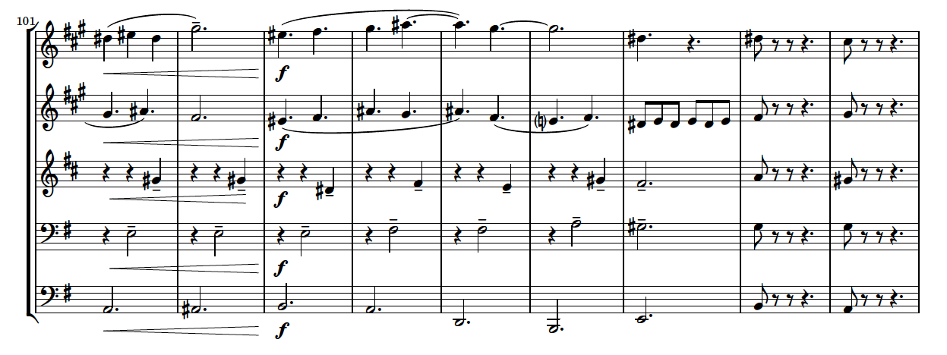

Trumpet 1

Trumpet 2

F Horn

Trombone

Tuba

*1*

*5*

*9*

(a) Write out **bars 3 - 6** of the **Trumpet 2** line so that it could be played by a Flute and sound at concert pitch. (3 marks)

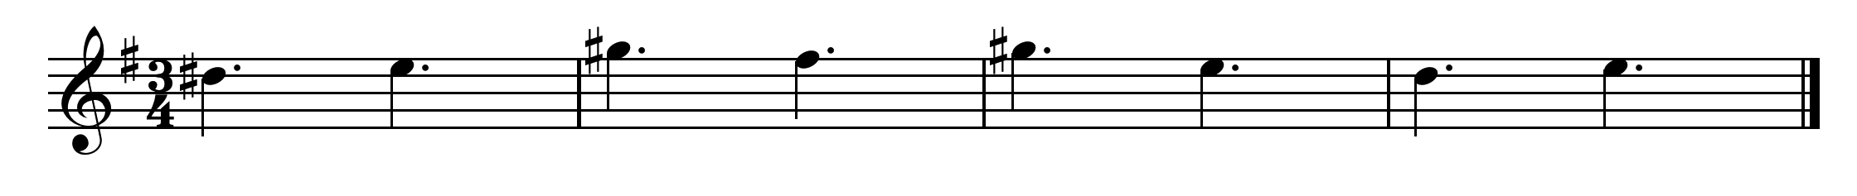 Answer as above.

1 mark for correct clef (preferably in octave as above, but accept lower octave)

1 mark for correct notes

1 mark for correct accidentals

**Total of 3 marks**

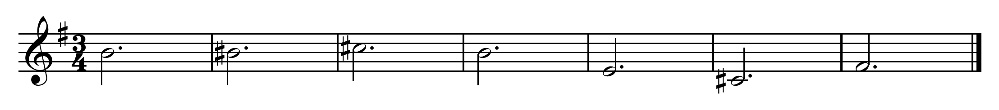(b) Write out **bars 1 – 7** of the **Tuba** line so that it could be played by a Trumpet (treble clef) and sound at concert pitch. (3 marks)

Answer as above.

2 marks for correct notes (1 mark bars 1-3, 1 mark bars 4-7)

1 mark for correct accidentals

**Total of 3 marks**

**Question 14: Theory (5 marks)**

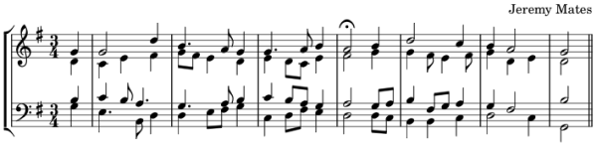Refer to the questions below to complete the following SATB setting.

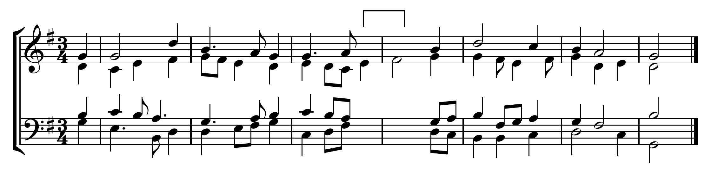

____

____

(a) Where indicated, complete the score above with a cadence, using correct SATB setting rules.

(i) Add the missing pitches on the stave underneath the bracket. (2 marks)

Accept all appropriate SATB setting with correct voice-leading

Acceptable chord progressions would be:

ii – V

IV – V

vi – V

1 mark per appropriate chord/SATB setting

(ii) Write the name of each chord (as a Roman numeral) on the lines underneath the stave.

(2 marks)

See part (i)

1 mark per appropriate chord

(b) Name the cadence you completed in this SATB setting. (1 mark)

See part (i)

1 mark for correctly naming an Imperfect Cadence

**Question 15: Melody writing (14 marks)**

Compose an **eight (8)** bar melody for Cello below by continuing the opening two bar motif for a further six bars. Consider the chords provided beneath the stave when writing your melody.

Your melody must demonstrate:

* Effective melodic contour and climax (4 marks)

* A clear relationship to the given chord structure (3 marks)

* Stylistic and motivic continuity (2 marks)

* Instrument range and suitability (2 marks)

* Appropriate expresses devices, including tempo, dynamics and articulations (3 marks)

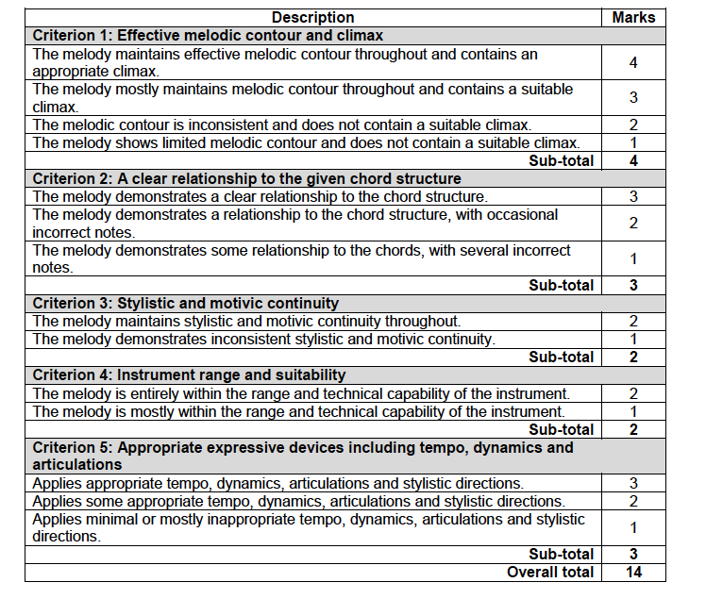

Marking key courtesy of the School Curriculum and Standards Authority

End of examination.